**S.6 BIOLOGY PAPER 1**

**TIME:21/2HOURS**

NAME……………………………………………………………………………………… STREAM…………………

**Instructions:**

* Answer all questions in section A and B
* Put the alternative showing the most correct answer in the box on the right of each question

**SECTION A (40 MARKS)**

1. Which of the following statements concerning human red blood corpuscles is false?
2. Contain the red pigment hemoglobin
3. Are destroyed by the liver
4. Lack a nucleus when mature
5. Are spherical in shape
6. A trio –ventricular and semi lunar valves
7. Ensure supply of blood to the heart muscle cells
8. Keep blood moving in one direction in the heart
9. Separate the left from the right ventricles and atria
10. Ensure supply of blood to skeletal muscle
11. The more variation in a population, the greater its potential to
12. Give rise to gene flow
13. Adapt to new changes in its environment
14. Produce more males
15. Be wiped away by an epidemic
16. In phototropism
17. Auxin is inactivated on the lightened side
18. More auxin is synthesized on the darkened side
19. Light initiates a redistribution of auxin in the zone of elongation
20. Light initiates a redistribution of auxin in the apical meristem
21. Which of the following is an adaptation to aquatic environment?
22. Long roots
23. Lack of stomata
24. Large cortex with closely packed cells
25. Well-developed xylem
26. In photosynthesizing plant cells, the light dependent and the light-independent reactions take place in the …………………respectively.
27. Nucleoplasm and cytoplasm
28. Cytoplasm and stroma
29. Plasma membrane and grana
30. Grana and stomata
31. Most mutations in organisms are;
32. Recessive and advantageous
33. Recessive and of no advantage
34. Dominant and advantageous
35. Dominant and of no advantage
36. Control of breathing rate in mammals
37. Largely according to the level of carbon dioxide in the blood
38. Under entirely voluntary control
39. According to the blood pressure in the arteries
40. Largely according to the level of the oxygen in the blood
41. Which series of steps best describes the path of a reflex arc?
42. Sensory neurone, stimulus, synapse, motor neurone
43. Stimulus, receptor, sensory neuron, synapse, motor neuron, effector
44. Stimulus, receptor, sensory nuerone, motor nuerone, synapse, effector,
45. Stimulus, receptor, sensory nuerone, synapse, effector, motor nuerone
46. Plant cells which are thin-walled, can photosynthesis, store food and secrete substances belong to
47. Parenchyma
48. Collenchyma
49. Cambium
50. Xylem
51. The change of colours in a chameleon is an example of
52. Cryptic coloration
53. Mimetic coloration
54. Flash coloration
55. Warning coloration
56. Which of the following play no defense roles in mammals?
57. Lymph nodes
58. T cells(lymphocytes)
59. Platelets
60. Erythrocytes
61. The primary connection between the nervous system and the endocrine system is
62. The hypothalamus
63. The brain
64. Adrenal gland
65. Thyroid gland
66. The pigment responsible for detecting the present or absence of light in plants
67. Photoflorin
68. Chlorophyll
69. Florigen
70. Photochrome
71. Stomatal closure is normally caused by.
72. Rising turgor of the
73. Increasing pH of the guard cell sap
74. Conversion of starch to sugar in the guard cells
75. Loss of guard cell turgor
76. Water flowing over the gills of a bony fish
77. Flows in the same direction as blood in the gills
78. Flows more slowly than the blood
79. Flows in the opposite direction to that of the blood
80. Loses only 0.5% of its dissolved oxygen to the blood
81. Hormones and enzymes are similar in that both
82. Are always secreted directly into the digestive system
83. Affect the rate of physiological processes
84. Are secreted only by endocrine glands
85. Convert carbohydrate to amino acids
86. Of the following activities which is the second event to occur in the depolarization of a nerve cell?
87. Na+ channels open and Na+ rushes inside
88. K+ channels open and K+ rushes outside
89. Negatively charged ions rush outside
90. K+ channels open and K+ rushes inside
91. During flight in big-sized insects, upstroke is brought about by
92. Contraction of direct flight muscles
93. Relaxation of indirect flight muscles
94. Contraction of indirect flight muscles
95. Sudden up thrust of the body
96. Which one of the following pairs of events occur together to increase the oxygen concentration in the alveoli of the lungs?
97. Contraction of diaphragm muscles and internal intercostal muscles
98. Relaxation of diaphragm muscles and internal intercostal muscles
99. Contraction of diaphragm muscles and external intercostal muscles
100. Relaxation of the diaphragm muscles and external intercostal muscles
101. The figure below shows changes in potentials in an axon membrane when an impulse is transmitted.

Direction of impulse

B

+ve

0 A

C

-ve D

At which stage of the electrical potential marked, is the axon most permeable to sodium ions?

1. The type of learning that involves the immediate understanding and responding is
2. Imprinting
3. Associative learning
4. Insight learning
5. Habituation
6. Starch, glycogen and cellulose are all composed of
7. Alpha- glucose
8. Beta- glucose
9. Monosaccharides
10. Polysaccharides
11. Which one of the following applies to the cones of the retina? They
12. Show visual acuity
13. Perceive dim light
14. Show much retinal convergence
15. Contain rhodopsin pigment
16. Which one of the following parasites is intercellular?
17. Taenia
18. Plasmodium
19. Ascari
20. Trypanosome
21. Which one of the following is the correct formula of a polysaccharide?
22. (C6H10O5)n
23. (CH2O) n
24. (C6H12O6) n
25. (C12H22O11) n
26. Myoglobin is more abundant in active muscles because it
27. Easily give up its oxygen to the muscles
28. Gives the colour of the muscles
29. Slowly releases oxygen to the muscles
30. Has a low affinity for oxygen
31. Which one of the following hereditary characteristics is known to be limited?
32. Hemophilia
33. Albinism
34. Baldness
35. Colour-blindness
36. In order to survive in the sea, a marine bony fish
37. Loses water by osmosis and absorbs salts
38. Swallows water and absorbs salts
39. Swallows water and extracts salts
40. Grains water by osmosis and extrudes salts
41. Which one of the following characteristics of a parasite would increase its chances of survival?
42. Being highly specific
43. Inflicting severe effects on the host
44. Parasiting more than one type of horst
45. Employing no vectors
46. Pancreatic juice contains the enzymes;
47. Lipase, amylase, pepsin
48. Lipase, amylase, trypsinogen
49. Amylase, pepsin, trypsinogen
50. Amylase, pepsin, trypsinogen
51. The end product of glycolysis is
52. Glucose diphosphate
53. Lactic acid
54. Citric acid
55. Pyruvic acid
56. The figure below represents a tetrapod in motion

2 1-a

5

3 4

If the animal limb a during its movement, in which position would it shift its Centre of gravity in order to remain most stable?

1. 2
2. 3
3. 4
4. 5
5. The camel family is found only in North Africa, Asia and South America. This is an example of
6. Adaptive radiation
7. Convergent radiation
8. Discontinuous distribution
9. Divergent distribution
10. Which one of the following structures is responsible for initiating the contractions of the heart?
11. Purkinje tissue
12. A trio- ventricular node
13. Sino atrial node
14. Heart muscle
15. In which one of the following does anaerobic respiration not occur?
16. Skeletal muscle
17. Yeast cell
18. Bacteria
19. Smooth muscle
20. Which one of the following is the MRNA strands that corresponds to the DNA strand TAGGCT?
21. AUCCGU
22. UUCCGU
23. CGAAUC
24. UAGGCU
25. Which one of the following is the correct route taken by blood on leaving the heart, in a single circulatory system?
26. Body heart gills
27. gills heart body
28. body gills heart
29. gills body heart
30. Termites are able to eat wood because they
31. Contain fungi in the gut
32. Contain cellulose digesting bacteria in the gut
33. Possess strong mandibles
34. Produce cellulose
35. The wave length from the light spectrum is mostly by absorbed by green plants?
36. Red
37. Green
38. Blue
39. Yellow

SECTION B

41.(a) Distinguish between anaerobiosis in plants and animals. (02 marks)

……………………………………………………………………………………………………………………………………………………………………………………………………………………………………………………………………………………………………………………………………………………………………………………………………………………………………………………………………………………………………………………………………………………………………………………………………………………..

b) Describe the fate of lactic acid in respiratory metabolism (02 marks)

……………………………………………………………………………………………………………………………………………………………………………………………………………………………………………………………………………………………………………………………………………………………………………………………………………………………………………………………………………………………………………………………………………………………………………………………………………………..

c) Explain the advantage of lactic acid accumulation in muscles during exercise. (02 marks)

……………………………………………………………………………………………………………………………………………………………………………………………………………………………………………………………………………………………………………………………………………………………………………………………………………………………………………………………………………………………………………………………………………………………………………………………………………………..

d) (i) Explain why very few plants can be complete anaerobes. (03 marks)

……………………………………………………………………………………………………………………………………………………………………………………………………………………………………………………………………………………………………………………………………………………………………………………………………………………………………………………………………………………………………………………………………………………………………………………………………………………..

ii) State one situation when plants carry out anaerobiosis. (01 mark)

……………………………………………………………………………………………………………………………………………………………………………………………………………………………………………………………………………………………………………………………………………………………………………………………………………………………………………………………………………………………………………………………………………………………………………………………………………………..

42. Figure 2 shows the metabolic rate of a resting dog at different environmental temperatures.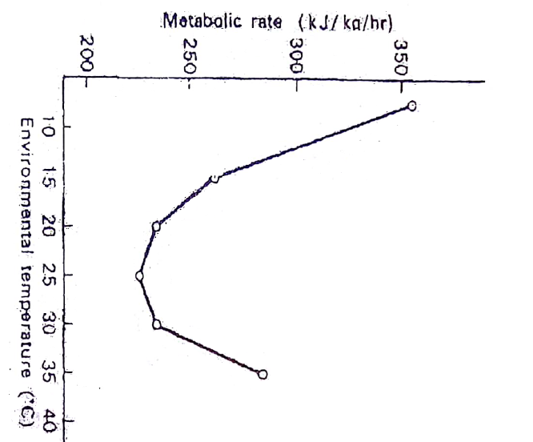

1. Describe the effect of increasing environmental temperature on metabolic rate. (04 marks)

……………………………………………………………………………………………………………………………………………………………………………………………………………………………………………………………………………………………………………………………………………………………………………………………………………………………………………………………………………………………………………………………………………………………………………………………………………………………………………………………………………………………………………………

1. Explain the change in metabolic rate between
2. 20o c and 30oc (02 marks)

……………………………………………………………………………………………………………………………………………………………………………………………………………………………………………………………………………………………………………………………………………………………………………………………………………………………………………………………………………………………………………………………………………………………………………………………………………………………………………………………………………………………………………………

1. Above 30oc (02 marks)

………………………………………………………………………………………………………………………………………………………………………………………………………………………………………………………………………………………………………………………………………………………………………………………………………………………………………………………………………………………………………………………………………………………………………………………………………………………………………………………………………………………………………………………………………………………………………………

1. Explain how the Carmel a desert mammal is specialized to meet the problems of overheating and water stress in its habitat. (02 marks)

……………………………………………………………………………………………………………………………………………………………………………………………………………………………………………………………………………………………………………………………………………………………………………………………………………………………………………………………………………………………………………………………………………………………………………………………………………………………………………………………………………………………………………………

43. Figure3 shows the comparative photosynthetic response of $C_{3}$ and $C_{4}$ plants to increasing light intensity and temperature.

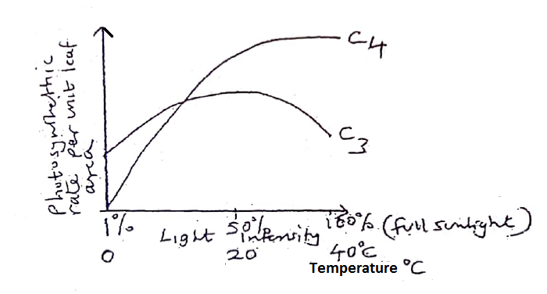

1. Compare the combined effect of light intensity and temperature on the photosynthetic rate. (03 marks)

………………………………………………………………………………………………………………………………………………………………………………………………………………………………………………………………………………………………………………………………………………………………………………………………………………………………………………………………………………………………………………………………………………………………………………………………………………………………………………………………………………………………………………………………………………………………………………………………………………………………

1. State the advantage of;
2. $C_{4}$ photosynthesis over $C_{3}$ photosynthesis (03 marks)

……………………………………………………………………………………………………………………………………………………………………………………………………………………………………………………………………………………………………………………………………………………………………………………………………………………………………………………………………………………………………………………………………………………………………………………………………………………………………………………………………………………………………………………………………………….

1. $C_{3}$ photosynthesis over $C_{4}$ photosynthesis (02 marks)

……………………………………………………………………………………………………………………………………………………………………………………………………………………………………………………………………………………………………………………………………………………………………………………………………………………………………………………………………………………………………………………………………………………………………………………………………………………………………………………………………………………………………………………………………………….

1. State the likely location of
2. $C_{3 }$ plants (01 mark)

……………………………………………………………………………………………………………………………………………………………………………………………………………………………………………………………………………………………………………………………………………………………………….

1. $C_{4}$ plants (01 mark)

………………………………………………………………………………………………………………………………………………………………………………………………………………………………………………………………………………………………………………………………………………………………………

44. Figure 4 shows a motor end plate together with associated muscle.

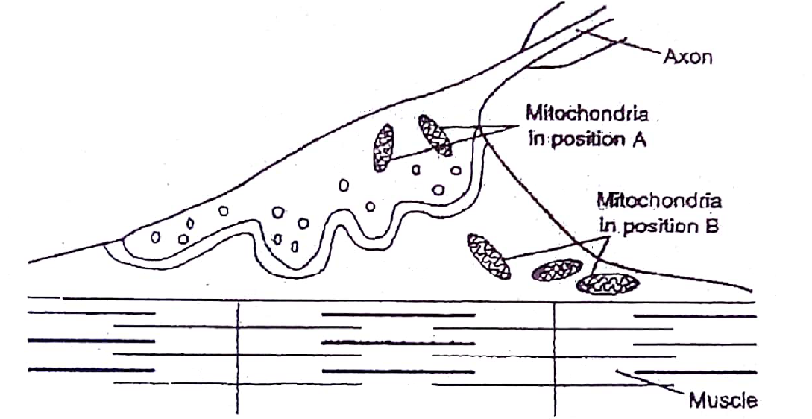

1. Describe how transmission of information occurs across the nerve muscle junction when an impulse arrives at the pre synaptic membrane (05marks)

………………………………………………………………………………………………………………………………………………………………………………………………………………………………………………………………………………………………………………………………………………………………………………………………………………………………………………………………………………………………………………………………………………………………………………………………………………………………………………………………………………………………………………

1. (i) What causes the banding pattern seen in the muscle fibril? (02marks)

………………………………………………………………………………………………………………………………………………………………………………………………………………………………………………………………………………………………………………………………………………………………………………………………………………………………………………………………………………………………………………………………………………………………………………………………………………………………………………………………………………………………………………

1. Explain the likely change in the banding pattern when the muscle fibril?

(03marks)

………………………………………………………………………………………………………………………………………………………………………………………………………………………………………………………………………………………………………………………………………………………………………………………………………………………………………………………………………………………………………………………………………………………………………………………………………………………………………………………………………………………………………………………………………………

45. (a) Explain what is meant by green house effect. (03marks)

………………………………………………………………………………………………………………………………………………………………………………………………………………………………………………………………………………………………………………………………………………………………………………………………………………………………………………………………………………………………………………………………………………………………………………………………………………………………………………………………………………………………………………………………………………

(b) State the harmful consequences of the following

1. Ozone layer depletion (03 marks)

………………………………………………………………………………………………………………………………………………………………………………………………………………………………………………………………………………………………………………………………………………………………………………………………………………………………………………………………………………………………………………………………………………………………………………………………………………………………………………………………………………………………………………………………………………………

1. Discharge of smoke in air from industries (03marks)

………………………………………………………………………………………………………………………………………………………………………………………………………………………………………………………………………………………………………………………………………………………………………………………………………………………………………………………………………………………………………………………………………………………………………………………………………………………………………………………………………………………………………………………………………………………

1. Suggest **one** way how ozone layer depletion has been minimized (01mark)

………………………………………………………………………………………………………………………………………………………………………………………………………………………………………………………………………………………………………………………………………………………………………………………………………………………………………………………………………………………………………………………………………………………………………………………………………………………………………………………………………………………………………………

46. (a) What is meant by polymorphism? (01mark)

…………………………………………………………………………………………………………………………………………………………………………………………………………………………………………………………………………………………………………………………………………………………………………………………………………………………………………………………………………………………………………………………………………………………………………………………………………………………………………………………………………………………………………………………………………………………………………

b) Biston betularia the peppered moth is light coloured and mottled. In 1848 a dark (melanic) mutant form was captured in Manchester by 1895 98% of these months in Manchester were melanic forms. The dark two forms are morphs, the normal form being *Biston betularia typica and* the dark form *Biston betularia carbonifera*

**Table 1 shows the observed frequency of the two morphs of Biston betularia**

|  |  |  |
| --- | --- | --- |
| **Habitat** | **typica** | **Carbonifera** |
| Rural woodland | 94.6% | 9.4% |
| Industrial woodland | 10.1% | 89.9% |

**Table 2 shows the observed frequency of predation of Biston betularia by woodland birds**

|  |  |  |
| --- | --- | --- |
| **Habitat** | **Typical** | **Carbonifera** |
| Rural woodland | 13.6% | 86.3% |
| Industrial woodland | 74.2% | 89.9% |

1. Comment on the distribution of the two forms of month as shown in table **1** (03 marks)

………………………………………………………………………………………………………………………………………………………………………………………………………………………………………………………………………………………………………………………………………………………………………………………………………………………………………………………………………………………………………………………………………………………………………………………………………………………………………………………………………………………………………………………………………………………………………………………………………………………………

1. How does the data in table **2** support the natural selection? (04marks)

……………………………………………………………………………………………………………………………………………………………………………………………………………………………………………………………………………………………………………………………………………………………………………………………………………………………………………………………………………………………………………………………………………………………………………………………………………………………………………………………………………………………………………………………………………………………………………………………………………………………...

1. Given that the data shown in table **2** was collected in the 1950s, would you predict similar figures if the investigation was to be repeated this year. (02marks)

…………………………………………………………………………………………………………………………………………………………………………………………………………………………………………………………………………………………………………………………………………………………………………………………………………………………………………………………………………………………………………………………………………………………………………………………………………………………………………………………………………………………………………………………………………………………………………………………………………………………………………………………………………………………………………………………………………………………………………………………………………………………………………………………………………………………………………………………………………………………………………………………………………………………………………………………………………………………………………………………………………………………………………………………………………………………………………………………………………………………………………………………

***END***

***I wish you the best!***